**Instruction Manual for Colposcope Camera**

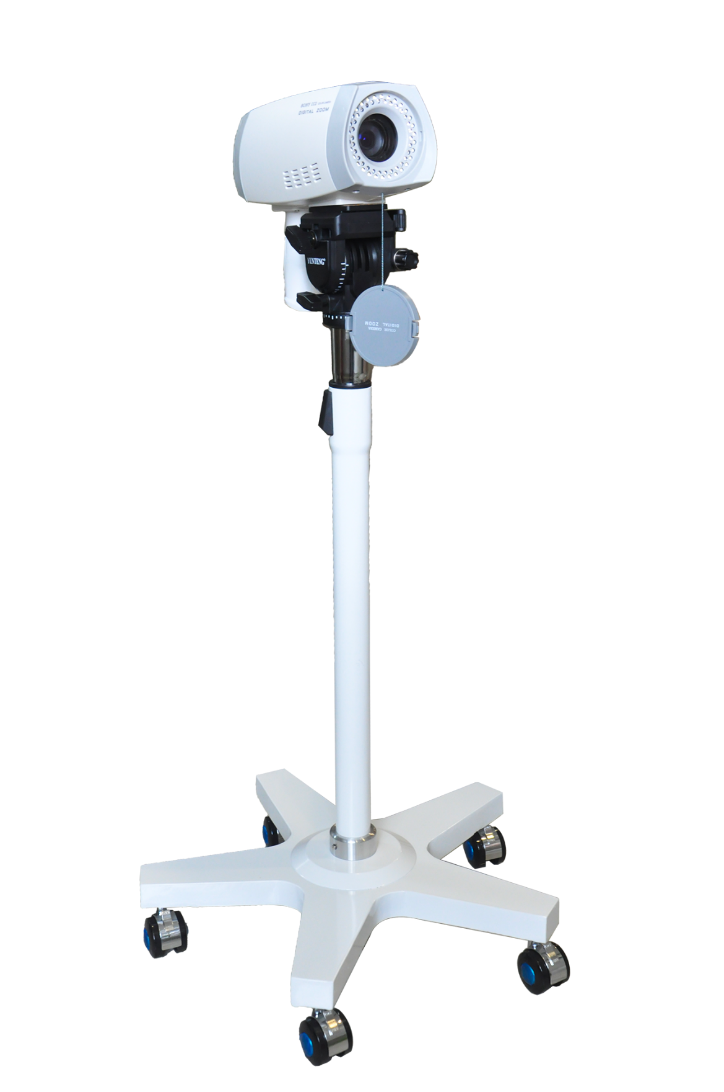

# 1. Detailed Contents for the Camera Bracket

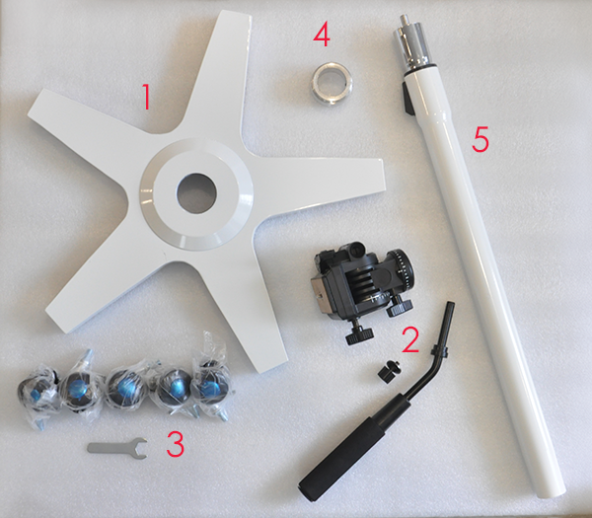

1. Bracket Base
2. Camera Support Head
3. Wheels (5pcs)
4. Circular Ring
5. Upstand Bracket

# 2. Detailed Contents for Colposcope Camera (Including Software)

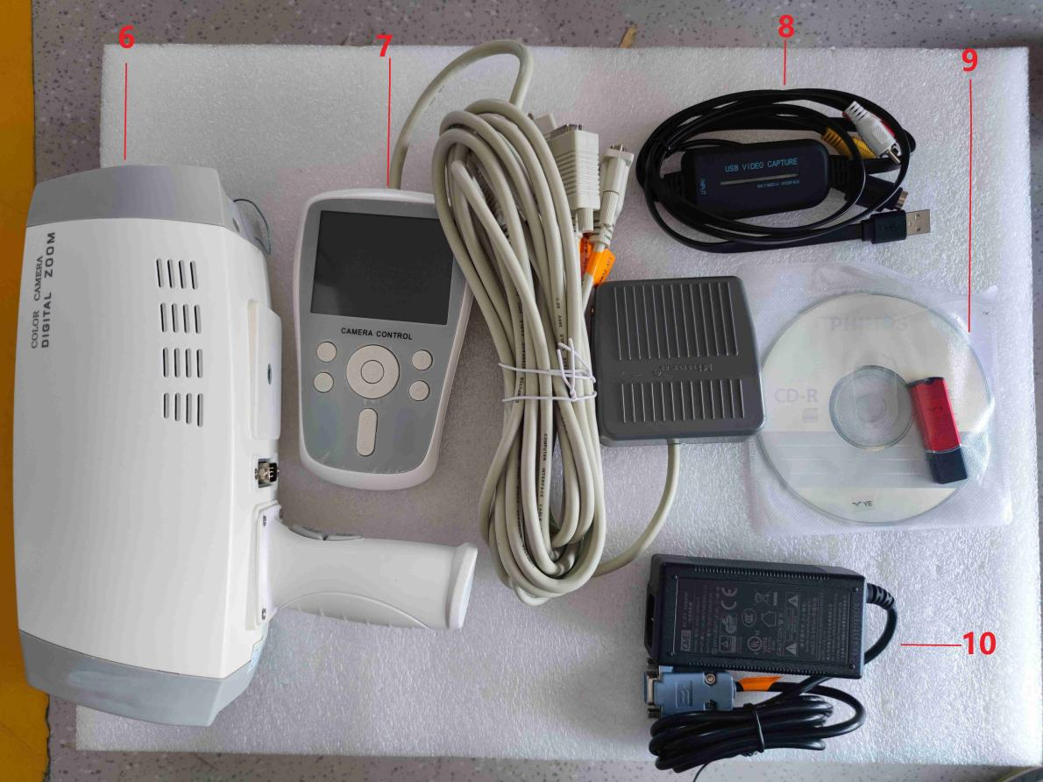

6.Colposcope Camera

7.Controller & Foot Switch

8.USB Capture Card

9.CCD Software and Softdog

10. 12V Portable Power Supply

# Installation for the Camera Bracket

* 1. 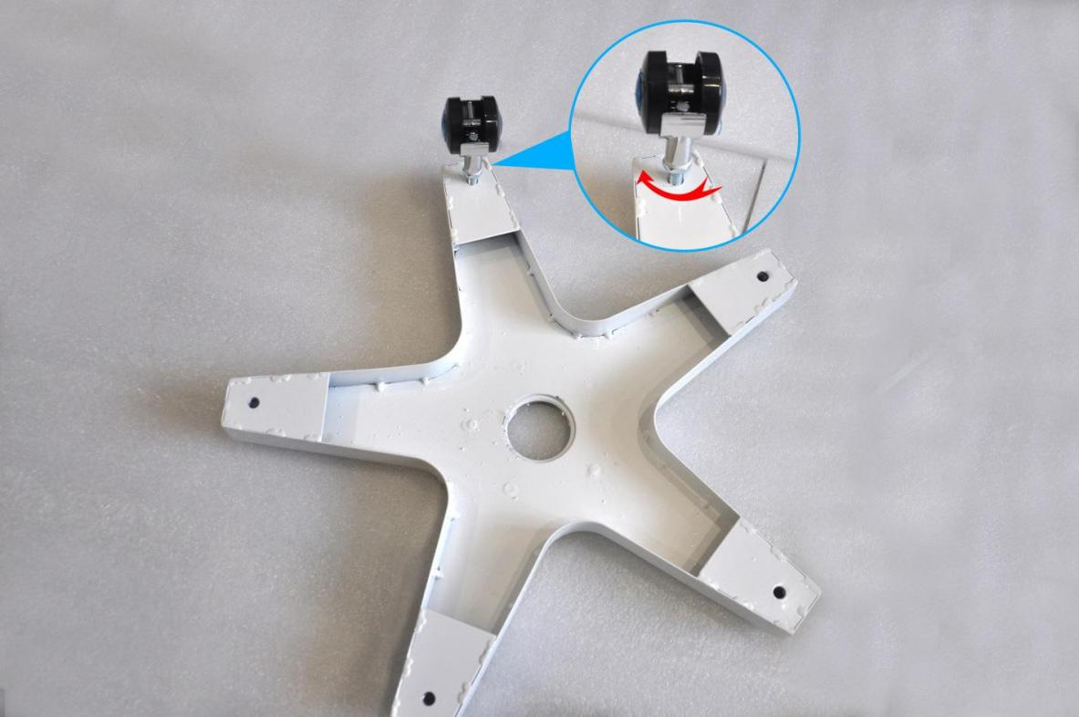Turn the Bracket Base over and turn the threaded segments of the 5 Wheels clockwise into the corresponding holes (as shown in following picture).
  2. Screw the threaded section of the Circular Ring clockwise into the corresponding hole in the center of the pentagonal base (as shown below)

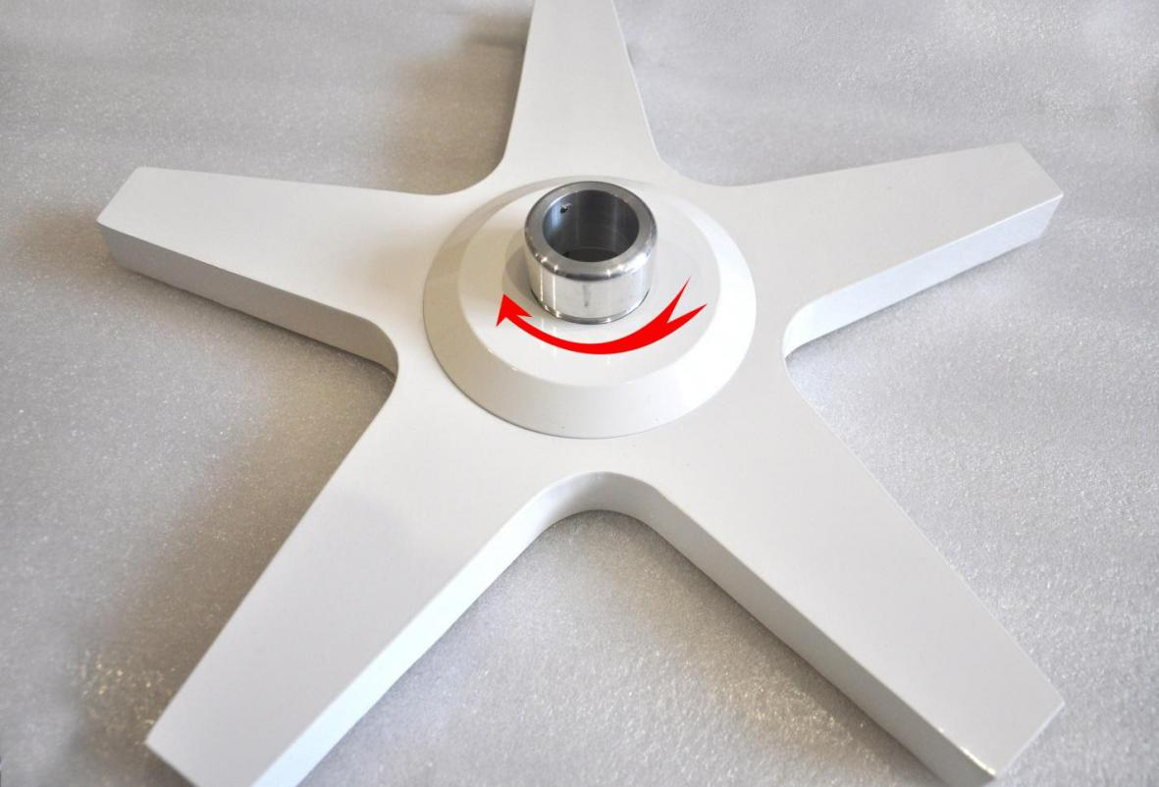

* 1. Insert the white end of the Upstand Bracket into the Circular Ring, and use a cross screwdriver to tighten the fixing screws on the side of the Circular Ring clockwise (as shown below)

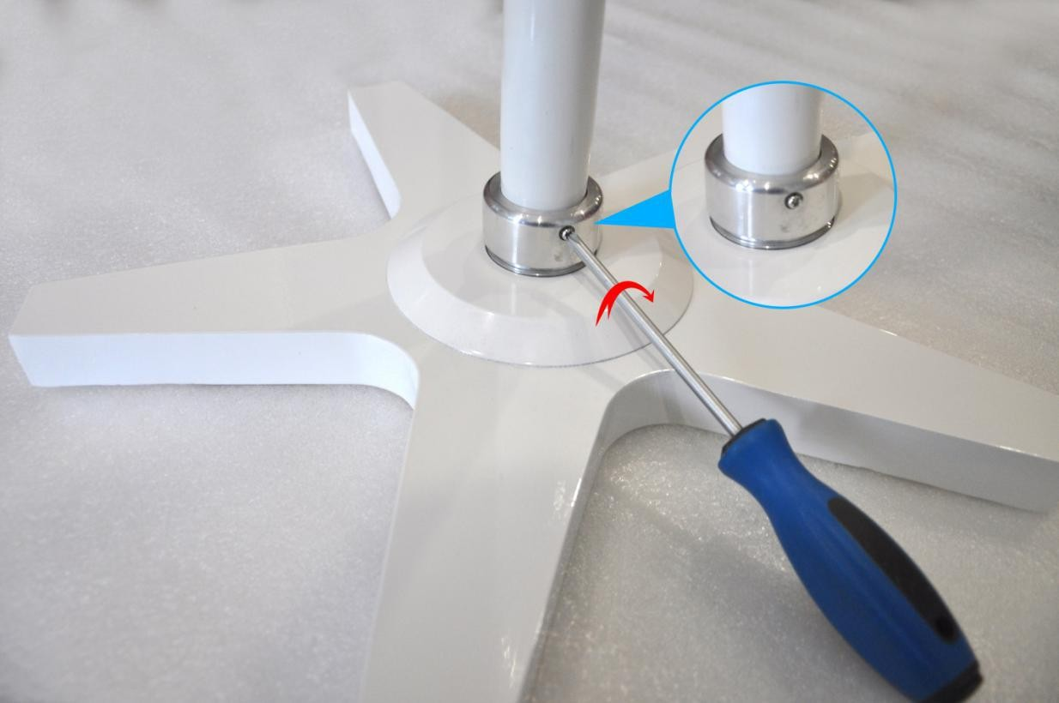

* 1. 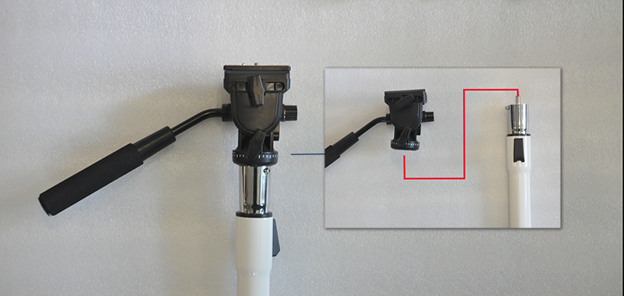Screw the threaded hole end of the Camera Support Head clockwise into the Upstand Bracket threaded column (as shown below)

# Installation for Colposcope Camera

First take off the control board by pushing the wrench, and install the control board to the threaded hole of the camera and screw it in clockwise (as shown below). And put the control board on the camera support head.

Remarks: Remember to lock the control board after you have put it well on the camera support head.

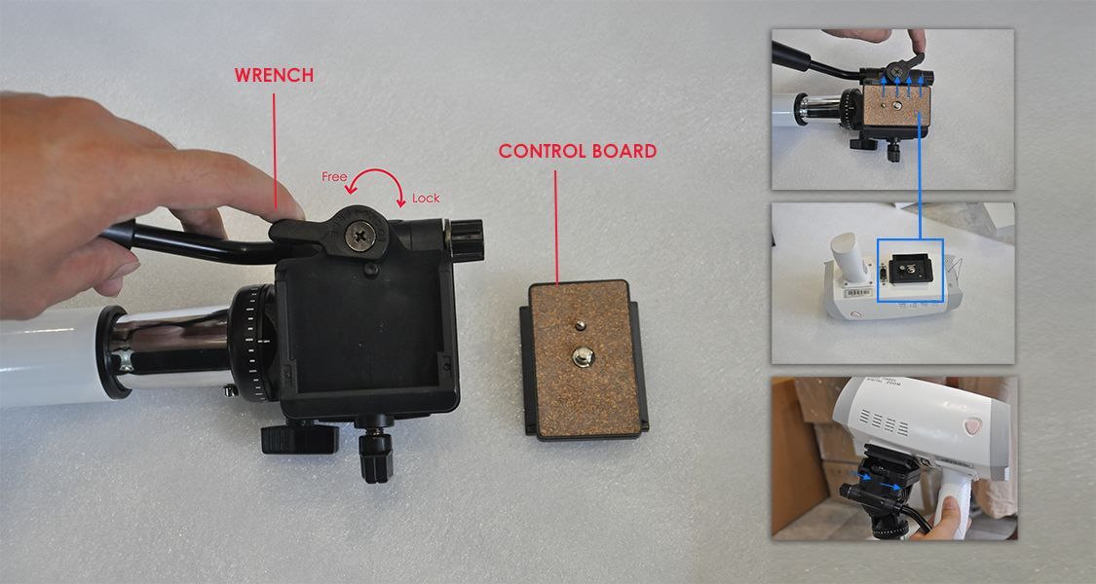

# Connect the camera cables as following picture.

①Connect 【Camera】with the colposcope camera

②Connect 【CVBS Video】with the yellow port of the USB video capture card

③Connect 【12V Power】 with the 12V Portable Power Supply

④Connect 【RS232 COM】with host of the computer.

If you want to connect with the laptop, please use the USB2.0 to RS232 Cable.

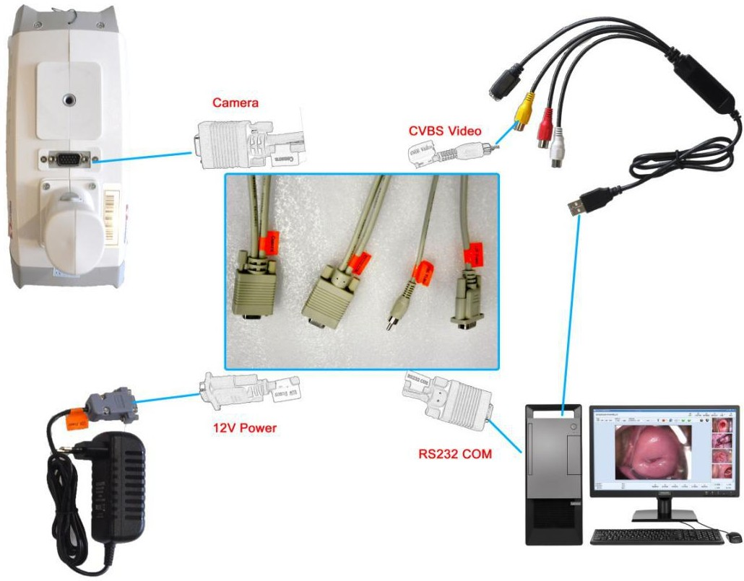

# Introduction of Controller

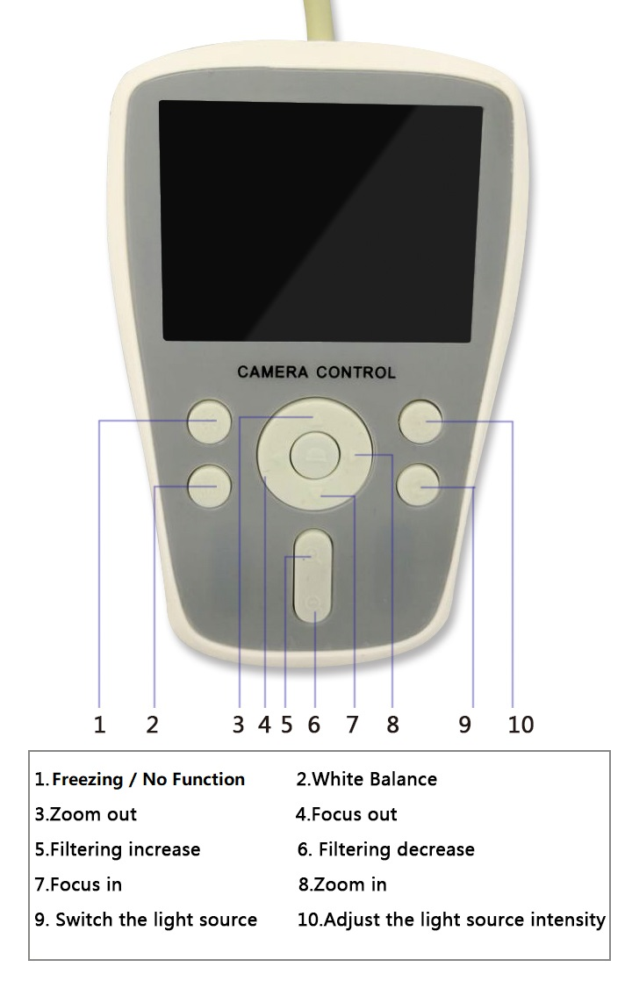

1. **Install the drive of the USB Capture Card and Colposcope Software**
2. Install the driver of the USB CAPTURE CARD and USB TO RS232 CABLE(IF NEED).
3. Install the colposcope software in the computer.
4. Insert the SoftDog in the computer, then run the software.
5. Check the COM Port (COM1, COM2, COM3...) in “**Device Manager**” of Computer, then keep the same COM Port in the software.

**System Settings--Capture Settings-Video Control** and **CaptureFootSwitch**

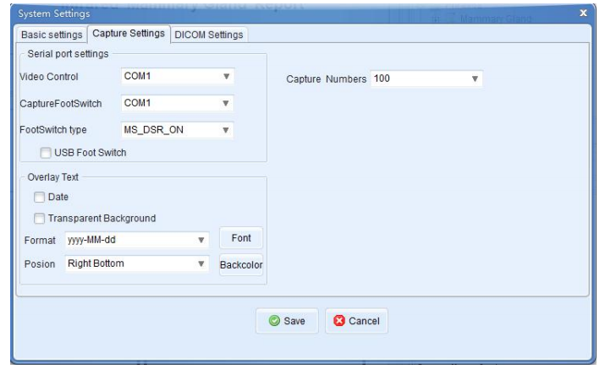

⑤Choose the CAPTURE CARD in the software.

**VIDEO SETTING--VIDEO SOURCE--”USB1150...”(choose your capture card)**

